Policy plan
Medi-Aid Holland Sri Lanka
2017-2018

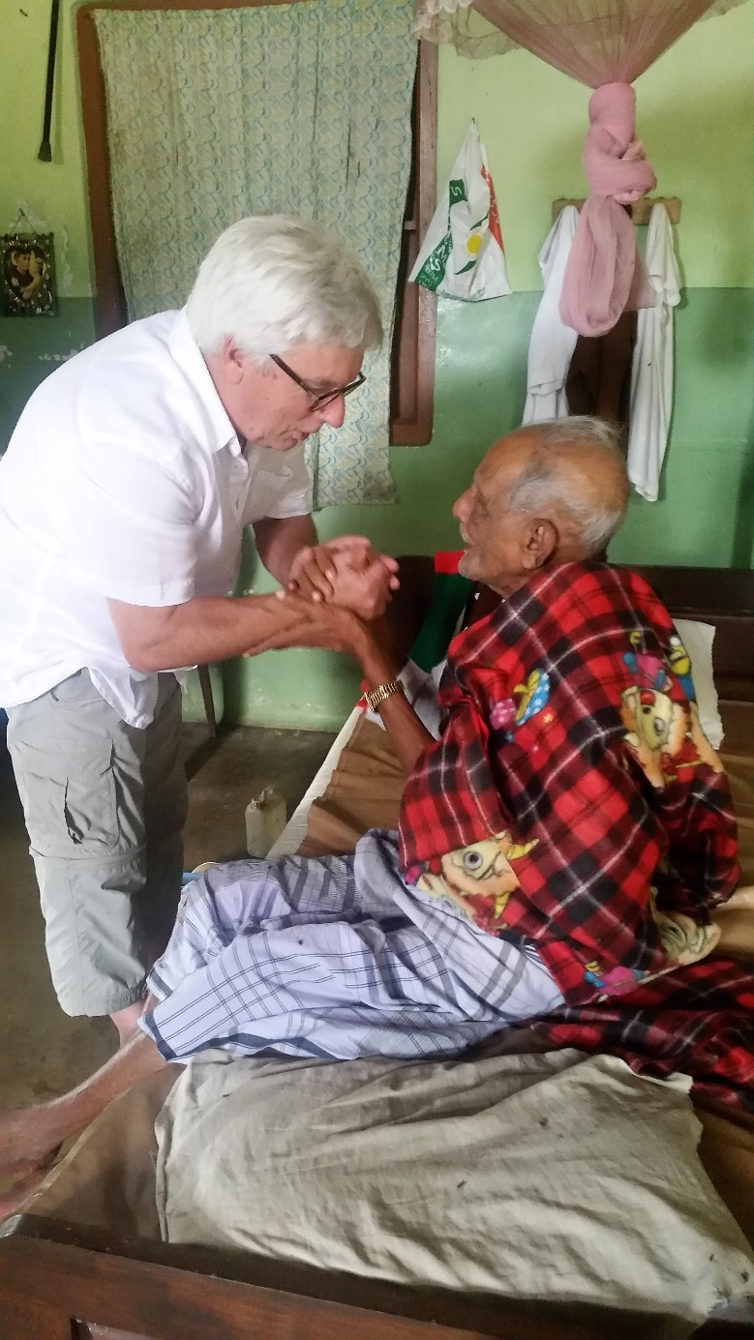

Index:

Chapter 1. The founding of Medi-Aid Holland page 2

Chapter 2. The Board in Sri Lanka page 2

Chapter 3. Mission and vision of Medi-Aid page 3

Chapter 4. Target groups page 3

Chapter 5. How Medi-Aid shapes her mission and vision page 4

Chapter 6. Cooperation page 5

Chapter 7. Fundraising page 6

Chapter 8. Medi-Aid information and board composition page 6

Chapter 1. The founding of Medi-Aid.

The idea to set up an aid organization to support the poorest and underprivileged in Sri Lanka goes back to the year 1999 when chairman Martin Joziasse first visited Sri Lanka. He was struck by the poverty that existed among a huge population and the glaring shortage of medical and nursing equipment in local hospitals.
At the same time, he realized how "normal" it is in the Netherlands to replace entire inventories in hospitals and nursing homes while there are still very usable. Back in the Netherlands he managed to seize material from an organization, shipped it to Sri Lanka and donated it to local hospitals, retirement homes and orphanages and many people were helped. The mission was there!
It soon turned out that this concept appealed to other institutions and individuals. Different types of materials were made available, like hospital beds, wheelchairs, walkers, large quantities of linens, clothing and toys. But not only material was offered, there were also institutions, businesses and individuals who wanted to take the transportation costs on their behalf.
From this moment on it was decided to structure more, coordinate and monitor by placing it in a foundation and would bear the name Medi-Aid Holland / Sri Lanka. In September 2002 was the admission and signing of the notarial association and Medi-Aid foundation was a fact. The foundation is registered at the Chamber of Commerce in Leiden Holland.

Chapter 2. The Board in Sri Lanka.

Assistance and support in Sri Lanka is not only about being confronted with sometimes inaccessible laws and regulations of Sri Lankan central and local authorities, but also the question of whether the support actually arrives where it is requested and required

To ensure the best possible overview, Sri Lanka has formed a board consisting of a number of influential Sri Lankans.
This Sri Lankan Board of Medi-Aid has an autonomous position, but accounts for the financial and material support that comes from the Netherlands and is held accountable to the Dutch board.

In all cases, the SL board initiates the help questions that come from Sri Lanka itself. If an emergency questionnaire has been submitted to Medi-Aid Holland, it will always be submitted first and then approved by Medi-Aid Sri Lanka.

Chapter 3. Mission and Vision of Medi-Aid.

Medi-Aid offers in Sri Lanka substantive and material support in the field of care and education to those who do not have the necessary resources or resources for whatever reason.
Medi-Aid does this to make an active contribution to improving the conditions in which people are looked after for, nursed or taken care of in Sri Lanka.
Through the contribution of Medi-Aid, we also aim to achieve improvement and professionalization of the elderly and disability care and to contribute to the employment and prospects of disadvantaged people.

Chapter 4. Target groups.

The target groups that support Medi-Aid include:

- Elderly people
- Poor people with special attention to young men and women whose future prospects improve through education provided by Medi-Aid.
- Young people / children with physical and / or mental impairment who, through proper and adapted material, have greater freedom of movement with all the positive effects of them.
- Local hospitals and orphanages, which by circumstances have no or no good material, which can’t provide care and nursing for patients and residents entitled.
- Sri Lankan organizations that provide care for elderly, disadvantaged and young people with care and where necessary nursing. The support of Medi-Aid takes place in order to improve all projects already financed and thus started

- Apart from focusing on the above target groups, there may always be emergency questions on Medi-Aid that include other areas of concern in a broad sense, for example in education or emergency aid in case of disasters. These help questions will only be considered after they have been submitted to the SL Board

Chapter 5. How Medi-Aid shapes her mission and vision.

- Content support.
Medi-Aid is the so-called 'Care Chain'. The Medi-Aid Foundation provides an organization in which care, and nursing are provided to older and poor Sri Lankans through Sri Lankans. An organization that, based on a material and intangible impulse by Medi-Aid, ultimately is self-supporting for the most part. This causes the knife to cut both ways: the less-favored and poor Sri Lankan elder receives the nursing and care he or she deserves, and it provides many Sri Lankan with employment. In addition, education also maintains not only the quality of service and care, but also maintains a continuous increase of newly qualified staff.
Content support, assistance in the form of broad-range care advice (including physical therapy and ergo therapy) is an important way to shape our vision and mission and the care chain ‘Training on the job’ Training on the job of upcoming nursing and caring staff is also part of the substantive support. As in the Netherlands, this vocational education focuses on the provision of knowledge and skills implemented and sponsored through expert guidance of volunteers from or through Medi-Aid.

- Material support.
In a long series of years, it has been found that substantive support simply does not come to an end if the necessary material and equipment is not present. Material support in the form of (para) medical and nursing equipment but also beds, lifts, wheelchairs etc. The availability of materials and equipment available locally can be made by collecting in the Netherlands and subsequently shipping and distribution in Sri Lanka and by collecting funds in the Netherlands and Sri Lanka and on-site. Material support is further elucidated below.

Note: In the above, there is no difference in importance: material support is a prerequisite for the substantive support!

2a Material support, guided by pre-formulated projects.
In the area of material support, the following is noted:
- We work exclusively on a project basis, a clear start and a clear end of the project.
- The material support projects will be formulated if there are questions for support from the SL Board. So, the initiator is always the board in Sri Lanka!
- A business case will then be drawn up, with fixed points:
  - Provides support to being ultimately self-supporting.
  - What has already been done in Sri Lanka
  - What is being done by the recipient himself?
  - Of course, the question is also raised or collected in the Netherlands and shipped, or collecting funds (in the Netherlands and in SL) and on-the-spot material / equipment.
- Questions for support can also be communicated to other active foundations in cooperation, if they are better qualified for this purpose.

- Volunteers
The support described above is provided by volunteers who work on behalf of and under the responsibility of Medi-Aid.
There is no separate volunteer policy in this policy plan:
From project to project, the Board of Medi-Aid assesses on what basis (or not based on cost compensation) the volunteers operate.

Chapter 6. Cooperation.

Medi-Aid looks, were possible and opportune for cooperation with other active foundations in Sri Lanka. Medi-Aid also visits the so-called 'Sri Lanka table' to establish or maintain contacts with other foundations.
Medi-Aid has a special collaboration with FHP (Family Help Program), which operates the Welcome Village. There is a cooperation agreement of Medi-Aid with FHP which is briefly referred to.
The Welcome Village that offers (nominal) shelter for 300 elderly and / or disadvantaged people has an infrastructure that, if arranged, can serve excellent support for the substantive support that Medi-Aid wants to offer.
It is a difficult time for The Welcome Village, but there is a chance that a restart and renovation will be possible. In the fall of 2017 this must be clear. A restart and refurbishment are preferred by Medi-Aid as it is the ideal of achieving a care chain: interrelated care and service facilities run by Sri Lankans for Sri Lankans, can best be achieved there!
Or, and if so, how the cooperation with FHP will continue, will be reviewed in the course of 2018.

In the short term the focus will be on Welcome Village, but Medi Aid will keep an eye on questions for support from other angles at all times!

Chapter 7. Fundraising.

With fundraising, Medi-Aid will always work on a project-based basis: a clearly defined goal is the most powerful motivation for money-givers!
Medi-Aid itself has funds in the Netherlands and in Sri Lanka, but will also do so in cooperation with other foundations.
Medi-Aid has the premise that it tests its projects based on Wild Geese foundation standards.

Chapter 8. Medi-Aid information and board composition.

Address: Straatweg 22, 3621 BN, Breukelen
Phone: 0031619989250

E-mail: martin_lanka@hotmail.com

Website: www.medi-aid.nl

Bank
IBAN: NL35INGB0661870839
BIC: INGBNL2A

Chamber of commerce Leiden: 28095859

ANBI: 812854159

Board composition Medi-Aid Nederland:

Dhr. M. Joziasse -chairman
Dhr. J. Wartna -secretary
Mevr. G. Pel -treasurer
Mevr. C. van den Heuvel -marketing and communication
Mevr. C. Hoffmans -curriculum development and sponsorship
Dhr. B. Verkuil -curriculum development and sponsorship
Dhr. E. Hamer -website management?

Board composition Medi-Aid Sri Lanka:

Dhr. W. Karunaratna -chairman
Dhr. M. Fernando -secretary/treasurer
Dhr. A. Tissera -member
Dhr. R. Wickramasinghe -member
Mevr. L. Sumanasena -member

